Memorandum
Identifying Information: | Adjustments for Occurrences of Salinity and Alkalinity

Tax Type: | Property Tax
Brief Description: | Adjustments for Occurrences of Salinity and Alkalinity
Keywords:
Approval Date: | 06/30/1998

Body:
MEMORANDUM
TO: All County Appraisers
FROM: Mark S. Beck
Director, Division of Property Valuation
DATE: June 30th, 1998
SUBJECT: Adjustments for Occurrences of Salinity and Alkalinity
The following table (on the back of this sheet) is based on the recommendation of a soil scientist and is designed to correct the reduced productivity of the areas identified as being affected by salinity or alkalinity. Only specifically identified areas where the salinity / alkalinity is hindering the normal cropping practice can be adjusted. Those areas will need to be delineated on your agricultural use maps.
The landowner will need to obtain laboratory data showing the Sodium Absorption Ratio (SAR) or Electrical Conductivity (EC). Either the SAR or the EC value, but not both for the same soil layer. The soil layer with the largest percentage reduction should be used to adjust the identified area.
The landowner must obtain laboratory data for the 0-8 inches, 8-24 inches, and the 24-40 inches layers as a minimum. All three soil layers are required before a reduction can be considered. These analysis can be obtained from the K-State soil testing lab, Servi-Tech, and other laboratories.
Based on responses from our recent phone survey, we are recommending the affected area be a minimum of three acres in order to receive an adjustment. If the parcel is irrigated do not adjust below the corresponding dryland value. Additionally, the dryland value cannot drop below $10.00 / acre.
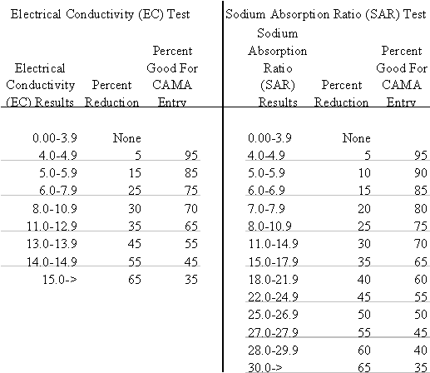
Date Composed: 07/22/1998 Date Modified: 10/09/2001

